- Gather requirements and initials information

Purpose: To help CS/CIS/BINF students and faculty coordinate study sessions, match with study buddies, and prepare effectively using syllabus-based flashcards.

Users:
- Students / Study Buddies: Create profiles, propose sessions, accept invites, review flashcards.
- Faculty: Organize study teams, share availability, approve groups, host office hours.

Key Features:
- Profile creation and availability upload
- Study buddy matching and session proposal
- Invite acceptance with deadline enforcement
- Faculty-led team organization and event creation
- Flashcard generation from syllabus topics between DATE1 and DATE2
- Automatic cancellation and notifications if invite deadline is missed

- Outline the system
Architecture: Command-line application using Python classes (Profile, StudySession, FlashcardGenerator) with interactive terminal prompts and printed output.
User Interaction: Users interact with the app via terminal input (e.g., typing names, dates, choices). Output is displayed as formatted text (e.g., session status, flashcards, notifications). No graphical interface or web page will be used.

Workflow Summary: Students create profiles and upload availability via terminal prompts. Faculty actions (team organization, event creation) are simulated through backend logic. Study sessions are proposed and accepted/declined via terminal input. Flashcards are generated and printed based on syllabus topics between DATE1 and DATE2. Auto-cancel logic and notifications are displayed as terminal messages
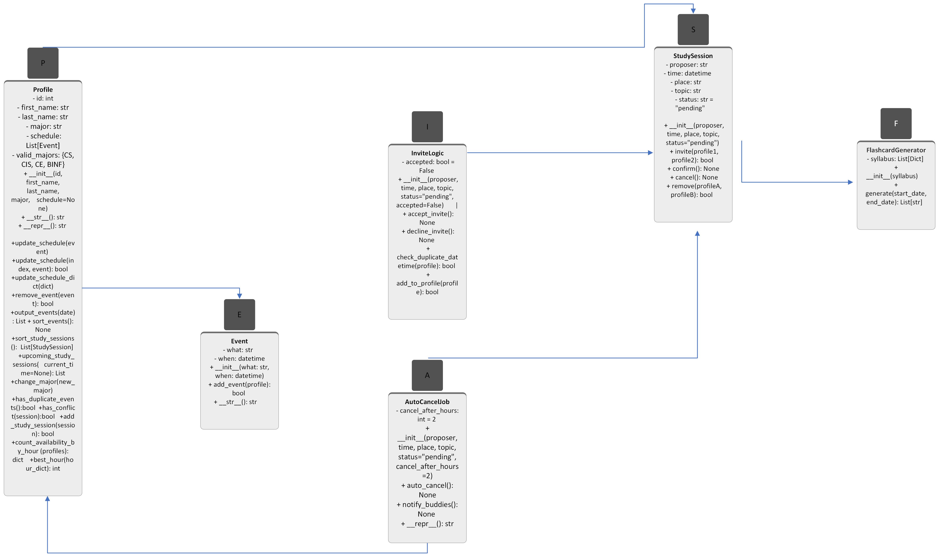

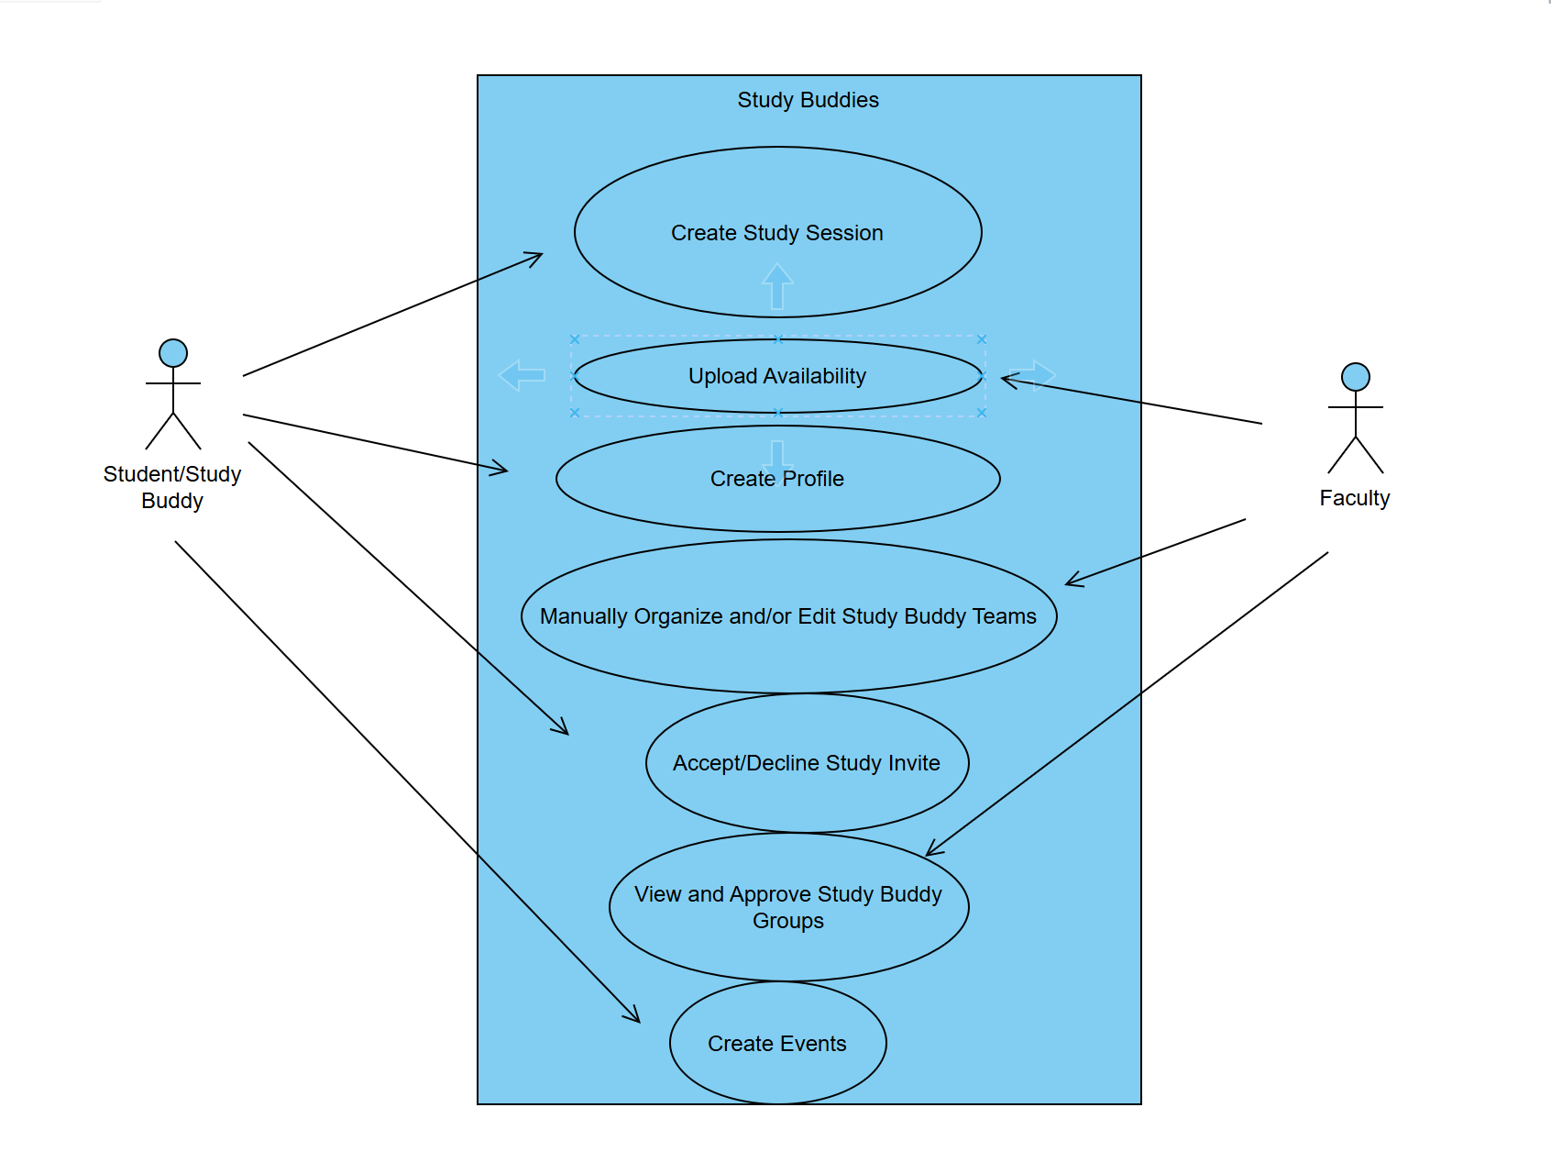
User Stories And Cases
#63 Create a driver that has an ASCII art welcome message

#59 As a student, I want to create a profile with my major and class schedule so that I can find compatible study buddies
Create a Profile class that has attributes: id (int), first name(str), last name(str), schedule (list (Event)), major (str). Create a constructor and a _str_ method. The first and last names must be formatted in Titlecase. The major must be formatted in TITLECASE. The schedule must begin as an empty list.
Create an update schedule(index: int, Event) that changes the element at the given index with the provided Event. Also create a method to change the major. Don't update the event if it has the same DateTime as another DateTime in the schedule list.
Create 5 Profile objects and call every one of the Profile methods in the driver.
Write separate unit tests to test: (1) the profile has an id, first name, last name, major, (2) the update schedule method updates the schedule, (3) that all the DateTimes are valid, (4) the major is either CS, CIS, CE, or BINF, and (5) the first and last names use Titlecase.
Test that the profile doesn't have any duplicate Event objects.
Test that the profile doesn't have any events scheduled at the same DateTime.

#64 Update driver so it randomly creates 111 student profiles and then outputs the student(s) with the longest schedule

#60 As a student, I want to create study sessions so another student available at the same time can automatically join or cancel the session
Create a StudySession class that has time (DateTime), place (str), and reason (str) attributes. Create a constructor and _str_ methods.
Create an invite method that given two Profile objects, adds this study session to both profiles if the given DateTime is not already in both Profile objects' schedule.
Create a remove method that given two Profile objects, removes this study session from both profiles if the given StudySession object is in both Profile objects' schedule.
Test that the constructor only creates an object if all 3 attributes are given and none of the strings are empty.
Test that the str method displays using the format "Friday, Nov 21, 2025 at 11:28 PM has a study session on 'How to write use cases'".
Test that an invite stores no duplicate DateTime in a Profile object.
Test that a remove doesn't remove anything from either Profile object if the provided DateTime is not in both Profile objects.
Create a driver that generates 30 random StudySession objects, creates 2 Profile objects, stores 10 study sessions in the first profile, 10 study session in the second profile, and then invites both profiles to the final 10 study sessions.

#66 Update the driver to randomly create 33 study sessions and successively remove those sessions from any 2 randomly selected profiles

#62 As a student, I want to create events for others to join me
Create an Event class that has attributes: what (str) and when (DateTime). Create a constructor and str_ methods.
Create an add_event method that adds an event to the student's schedule. Don't add if the event is already in the student's schedule or the student already has something scheduled at that DateTime.
Create a remove_event method that removes all events in the schedule that have the same what attribute as the given event.
Create a sort events method that sorts the events in a given Profile object. Sort the events in reverse chronological order.
Create an output_events method that outputs the event in a given Profile object. In the output, prepend "LATE" to the what attribute of any events earlier than the current date and prepend "NOW" to the what attribute of any events on the current date. No event should be modified.
Create a driver that calls all the Event methods at least twice.

#65 Update the driver to randomly create 222 study sessions and then randomly select any 2 profiles to study the same study sessions

Product Backlog

#58 As a buddy, I want to accept or decline the X hour deadline so sessions can be confirmed or cancelled
Create accept/decline options
Test pending session auto-cancels after X hours
Test decline
Test accept before deadline
Test cancellation notifications

#22 As a faculty member, I want to upload my availability, so SBs can quickly book a Guided(physical or virtual)study session if needed

#51 As a student, I want to automatically generate flashcards from my syllabus between DATE1 and DATE2 so that I can review key topics before my study session

#44 Test: Session Proposals Store Time/Place/Topic

#46 Test: Pending Session Auto-Cancels After X hours

#43 Test: Schedule Updates Persist

#45 Test: Decline Invitation

#47 Test: Cancellation Notifications

#48 Test: Flashcards Generate Only for DATE1-DATE2

#61 As a student, I want my pending session request to be automatically cancelled if it isn't accepted within X hours, so that I can avoid waiting indefinitely and reschedule quickly

#20 As a faculty member, I want to view and approve study buddy groups to ensure balance teams

#19 As a faculty member, I want to manually organize or edit study buddy teams

S.M.
#67 As a student, I want the system to notify me when I have an event scheduled for the current day so that I do not forget important meetings or study sessions. The system should clearly highlight events occurring today when schedules are shown.

S.M.
#68 As a student, I want the system to prevent me from scheduling two events at the same time so that my schedule remains accurate and conflict-free. The system should reject any event that uses a duplicate date and time and inform the user when this conflict occurs.

S.M.
#69 As a student, I want the ability to view only the events scheduled for the current day so that I can quickly focus on what I need to complete without looking through my entire schedule. Only events for the current date should appear, while past events may be marked late and future events should not be displayed.

A.P.
#70 USE CASE 1 — Role-Based Login Screen
Actor: Student or Faculty
Goal: Allow users to log in as either Student or Faculty.

Preconditions: User has an account.
Description: Includes username, password, role selector (Student/Faculty), login button, and error messages.

Acceptance Criteria:

Role must be selected before login.

Student navigates to Student Dashboard; Faculty navigates to Faculty Dashboard.

A.P.
#71 USE CASE 2 — Faculty Dashboard Home Display

Actor: Faculty
Goal: Provide a dashboard for managing sessions, office hours, and study groups.

Preconditions: Faculty is logged in.
Description: Shows upcoming sessions, pending student requests, office hours section, and navigation menu.

Acceptance Criteria:

Faculty-only features visible.

Layout consistent with existing student dashboard

A.P.
#72 USE CASE 3 — Faculty Study Group Creation Display
Actor: Faculty
Goal: Allow faculty to create study groups with selected students.

Preconditions: Student list exists.
Description: Includes student selection, group name, topic, meeting time, location, create/cancel buttons.

Acceptance Criteria:

All fields required before creating a group.

Confirmation message after submission.

A.P.
#73 USE CASE 4 — Faculty Office Hours Management Display

Actor: Faculty
Goal: Add, edit, or remove office hours available to study buddies.

Preconditions: Faculty is logged in.
Description: Displays existing office hours, “Add Office Hour” form, and edit/delete actions.

Acceptance Criteria:

Multiple office hour blocks easy to add.

Edit/delete actions clearly visible.

A.P
#74 USE CASE 5 — Notification Center Screen
Actor: Student or Faculty
Goal: View all system notifications in one place.
Preconditions: User is logged in.
Description: Notifications include session invitations, cancellations, reminders, flashcard availability, etc.
Acceptance Criteria:
Notifications grouped by category.
“Mark as read” option available.
Clear timestamp on every notification.

L.H.
#75 As a student, I want to view an ordered list of all my upcoming study sessions so that I can plan my work and avoid missing important commitments.
Use Case 1 — Sort Study Sessions by DateTime
Actor: Student
Goal: Sort a list of StudySession objects from earliest → latest.
Preconditions: At least one StudySession exists in the student’s schedule.

Acceptance Criteria:

Sessions are sorted strictly by DateTime.

No StudySession data is modified.

Empty list returns empty list.

Order is stable (equal datetimes remain in original order).

Use Case 2 — Display Only Upcoming Study Sessions

Actor: Student
Goal: Return a list of sessions whose DateTime >= today.
Preconditions: Student must have at least one session.

Acceptance Criteria:

Past sessions are filtered out.

Today’s sessions are included.

Future sessions are included.

Returned data does not mutate original objects.

Use Case 3 — Unit Tests for Sorting + Filtering

Actor: Student (Tester)
Goal: Verify sorting and filtering behavior.

Acceptance Criteria:

Correct ascending order verified.

Today/future sessions appear as expected.

Past sessions are excluded.

Nothing breaks when schedule is empty.

L.H.
#76 As a faculty member, I want to view the distribution of students’ schedules so that I can determine the most optimal time to host guided study sessions or office hours.
Use Case 1 — Count Student Availability by Hour

Actor: Faculty
Goal: Generate a frequency count of how many students are available at each hour block.
Preconditions: Profiles contain Event or schedule entries with valid DateTime.

Acceptance Criteria:

Function returns a dictionary {hour: count}.

Hours with no availability appear with count zero OR are excluded (depending on design).

Uses DateTime .hour field.

Use Case 2 — Identify the Top Available Hour Block

Actor: Faculty
Goal: Determine the single best hour for hosting a guided session.
Preconditions: Availability count dictionary exists.

Acceptance Criteria:

Returns the hour with the maximum availability.

If a tie occurs, earliest hour returned.

Works even with small sample sizes (1–2 students).

Use Case 3 — Unit Tests for Availability Distribution

Actor: Faculty (Tester)
Goal: Confirm counting + top-hour calculation works.

Acceptance Criteria:

Hours are counted correctly.

Correct hour returned as most common availability.

Tie resolution works as expected.

Empty schedule returns None or a defined default behavior.

L.H.
#77 As a student, I want to quickly check whether a new study session conflicts with my existing events so that I can avoid double-booking myself.
Use Case 1 — Conflict Detection for New StudySession

Actor: Student
Goal: Check whether a new StudySession conflicts with any Event or StudySession already in the schedule.
Preconditions: Student has at least one Event or StudySession.

Acceptance Criteria:

Conflict = same DateTime.

Method returns True if conflict, False if not.

Does not mutate schedule.

Use Case 2 — Reject Conflicting StudySession Before Adding It

Actor: Student
Goal: Prevent adding sessions that overlap with existing DateTimes.

Acceptance Criteria:

Add only if no conflicts exist.

Return False on conflict.

Return True on success.

Schedule count increases only on success.

Use Case 3 — Unit Tests for Conflict Detection

Actor: Student (Tester)
Goal: Verify that conflict detection operates correctly.

Acceptance Criteria:

Adding a unique DateTime → succeeds.

Adding a conflicting DateTime → fails.

Schedule remains unchanged after failure.

System correctly identifies conflicts between:

Event vs. Event

Event vs. StudySession

StudySession vs. StudySession

Done
R.H.
#78 As a developer, I want to identify and comment-out failing unit tests in the tests directory, so that the tests run to completion.
Run the tests from the CLI.
If a test fails, comment it out.
Push the working version of tests to the repo.
Update README with the CLI command for running tests.

R.H.
#79 As a developer, I want to identify and comment-out any code in my driver that causes it to not print the start and end of the driver successfully to verify that the code can build and run in the CLI
Add print("Driver started") at the top of the driver.
Add print("Driver ended") at the bottom of the driver.
Run the driver from CLI ($python main.py) to verify both messages appear.
Comment out any crashing code until the driver runs cleanly.
Push the updated driver to the shared repo.’
Update README with the CLI command to run the driver.

- Detail the data design
Relationships:
- A Profile can propose multiple StudySessions
- A StudySession can invite multiple Profiles
- FlashcardGenerator uses syllabus data to produce flashcards for a session
- Specify the interface and component design
- The application runs entirely in the terminal using text prompts and printed output.
- Users interact by typing responses to prompts (e.g., name, major, session time).
- Output includes confirmation messages, session status updates, and flashcard lists.
- Review and refine the document with stakeholders
Checklist to Review
- All required features are covered
- MVP and MMP scope is defined and testable
- Add unit tests

